

De La Salle University

College of Computer Studies

Software Technology Department

**Rare Global Food Trading Corp.**

SOFTWARE REQUIREMENTS SPECIFICATION

|  |  |
| --- | --- |
| **Team Name** | **Team FONG** |
| **Section** | S22 |
| **Team Members** | Arceo III, Rodolfo S.  David, Liudger Franco D.  Flores, Jan Patrick L.  Fong, Hillary Ross C.  Lim, Thomas Kendrick V.  Mendoza, Dane T.  Ocampo, Royce Clarenz C.  Sey, Wayenard Y.  Tee, Paulina Grace C.  Valle, Jose Erin J. |
| **Date Submitted** | March 6, 2016 |

**Table of Contents**

|  |  |
| --- | --- |
| 1. Executive Summary | 1-1 |
| 1. Overview | 2-1 |
| * 1. Existing Business Process | 2-1 |
| * 1. Data Requirements   2. Existing Software or Tools | 2-2 |
| * 1. Roles in the Business Process | 2-4 |
| 1. Problem Analysis | 3-1 |
| 1. Software Solution | 4-1 |
| * 1. Objectives | 4-1 |
| * 1. Characteristics | 4-1 |
| 1. User Stories | 5-1 |
| * 1. User Story 1 - Add new client order   2. User Story 2 - View client orders based on due date and client name   3. User Story 3 - View all, pending, delivered client orders   4. User Story 4 - Modify client order   5. User Story 5 - Delete single client order   6. User Story 6 - Delete all delivered client orders   7. User Story 7 - Mark an order as delivered   8. User Story 8 - Add new product   9. User Story 9 - Modify product   10. User Story 10 - Delete product   11. User Story 11 - Search product   12. User Story 12 - View product of company   13. User Story 13 - Deposit or withdraw product from inventory   14. User Story 14 - Inventory history   15. User Story 15 - Modify inventory entry   16. User Story 16 - Delete multiple inventory entry within a date range | 5-1 |
| Appendix A - Improved Business Process | A-1 |
| Appendix B - Interview Transcript | B-1 |
| Appendix C - Sample Forms and Reports | C-1 |
| Appendix D - References and Acknowledgements | D-1 |

1. **Executive Summary**

Rare Global Food Trading Corporation is a company which provides imported meat and seafood to clients. It was started in 2012 by then sole proprietor, Mr. Jude Atienza, who is now the president. Three years later, the sole proprietorship became a corporation. Located at Rm. 1209 Entrata Bldg., Crimson Hotel, Civic Drive, Filinvest Corporate City, Alabang, 1781, Muntinlupa, the company is currently made up of 1 president, 1 treasurer, 1 corporate secretary, 2 managing directors, 1 executive secretary, and delivery personnels.

The company’s main service is to deliver various products of imported meat and seafood to different clients and establishments. Their priority is the health and safety of their customers and to provide good food quality. Some of the notable meat and seafood products that they deliver are: tuna, salmon, brisket, rib eye, and liver.

1. **Overview of the Business Process**

*This chapter presents the company’s business process and goals as an organization/department. Included in this chapter are the following items:*

* *Description of the company's existing process and business requirements*
* *Data requirements as part of the business process, including data that are captured, stored and generated (report formats should be placed in the Appendix)*
* *Existing software or tools used as part of the business process,*
* *Different roles in the business process*

***2.1 Existing Business Process***

Rare Global Food Trading Corporation provides meat and seafood products to various establishments. It orders meat and seafood from different suppliers, and delivers the products to its clients.

The process starts with receiving orders from customers via texts, phone call, email, or product order sheet. The orders are being placed in the client order Excel sheet (see appendix C-2) with details such as client name, product name, quantity, order receiver, and due date of the order if it is specified. The company then checks its supply in warehouse by going through the inventory Excel sheet (see appendix C-1) or calling a warehouse personnel. If the warehouse has stocks, the company proceeds to delivery.

The company calls its supplier and relays order information based on the client's order if no supply is found in its inventory. Suppliers notify the company if delivery can be made. If yes, the company updates the supplier order Excel sheet and places the supply order on the same day. The company calls its suppliers again if delivery cannot be made.

As the ordered products arrive at the warehouse, the warehouse personnel make sure if the delivery is correct. Warehouse personnel proceed to inspecting the delivery or they inform the office if the delivery is incorrect. The personnel receive a receipt from the suppliers after accepting the goods. They complete a deposit sheet (see appendix C-3) containing the details of the received goods. All delivery receipts and deposit forms are sent to the office before the end of the day and are handled by the secretary. The secretary updates inventory Excel sheet and client order Excel sheet. There are two inventory Excel file; one for meat, one for seafood. The secretary also moves the undelivered delivery to the next day.

For the delivery process, the company owners check what needs to be delivered during the day using the client order Excel sheet. The owners designate and allot delivery of goods to the delivery personnel. The products to be delivered are forwarded and requested to the warehouse personnel. The warehouse personnel search, gather, prepare the goods for delivery, and fill up the withdrawal form (see appendix C-4). The withdrawal sheets are sent to the office before the end of the day. The secretary receives the sheets and updates the inventory Excel file.

As the client receives the products, the client is asked to sign on a receive form (see appendix C-7) which comes in three copies. One copy of the receive form is given to the client. Other copies of the receive form are brought back to the office. The secretary keeps the forms and updates the client order Excel sheet accordingly. When the delivery personnel are unable to delivery the goods to the clients, they inform the company owner and bring back the goods to the warehouse. The undelivered products are deposited again, and a deposit form is issued.

At the end of the day, the company checks client order and inventory Excel file. It ensures that the withdrawal sheets match and reflect in the inventory and client order Excel sheet. File entries are deleted if they match with the withdrawal sheet. If entries do not match, they are not deleted and are further inspected. The company confirms this with a monthly warehouse check.

The business process can be visualized in the diagram shown in Figure 2-1 to Figure 2-3.

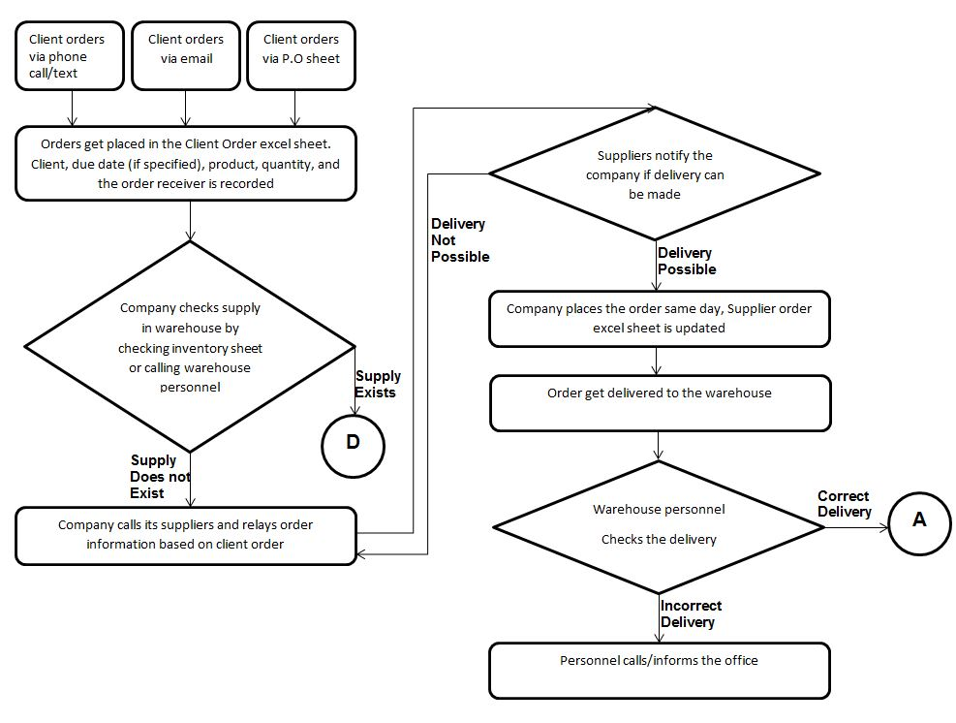

*Figure 2-1. Existing Business Process - Part 1*

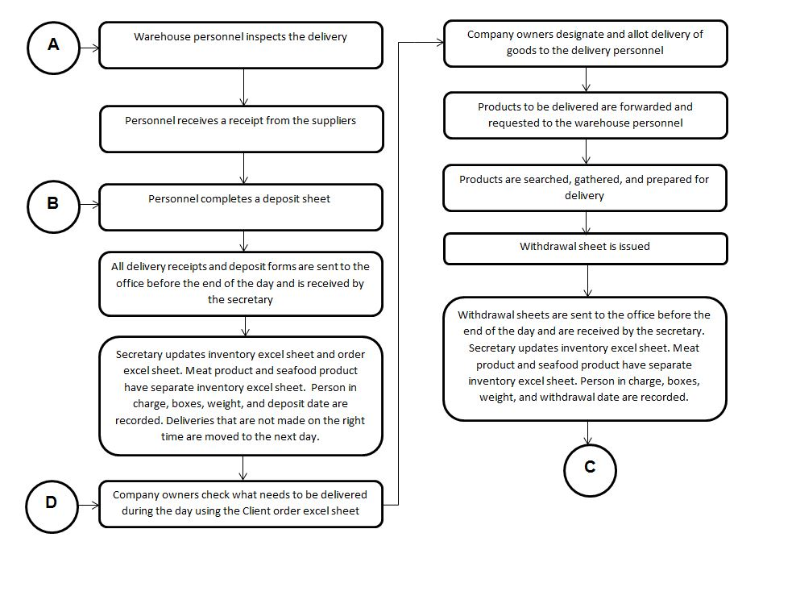

*Figure 2-2. Existing Business Process - Part 2*

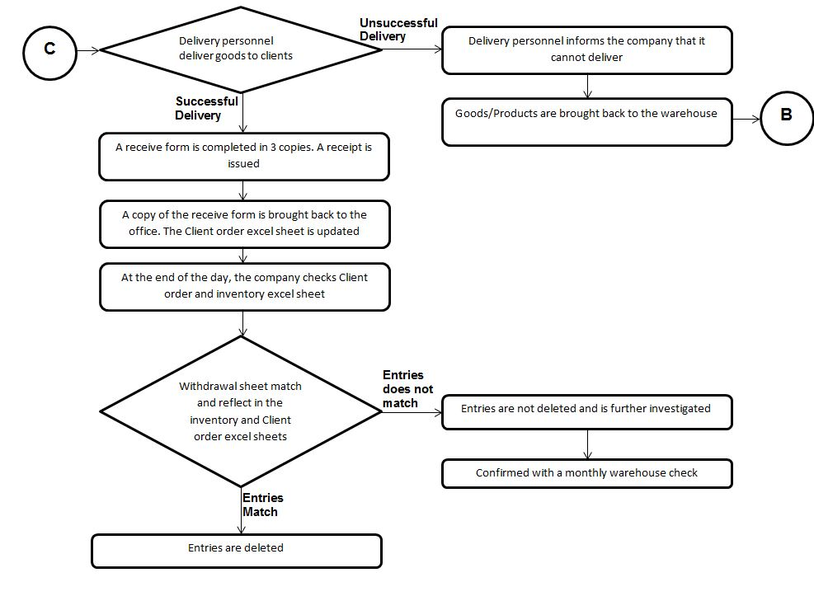

*Figure 2-3. Existing Business Process - Part 3*

***2.2 Data Requirements***

A deposit slip is a receipt like sheet that serves as the company’s form in storing a product in their warehouse. It contains information such as date, sheet control number, the name of products that was delivered to the warehouse, the total weight per product, the number of boxes per product, the total weight of the entire supply delivery, and the respective signatures of the warehouse checker and the client.

A withdrawal slip is a receipt like sheet that serves as the company’s form in removing a product in their warehouse. It contains information such as date, sheet control number, the name of products that is be withdrawn from the warehouse, the total weight per product, the number of boxes per product, special instructions, possibly some remarks, and the respective signatures of the warehouse checker and the client.

A receive form is a sheet that the company provides to the client upon payment of the delivery. It contains information such as sheet number, date, receiver name, receiver TIN, receiver address, sum of payment in words, sum of payment in numerical form, possible a partial fulfillment of another payment, payment form(Cash or Check), bank account, and is signed by the authorized representative

A sales invoice form is a receipt like sheet that the company provides to the client upon receiving of the ordered goods. It contains information such as sheet number, date, receiver name, receiver TIN, receiver address, PO number, quantity of goods, corresponding unit of measurement, items or products, unit price, total per product, total of the entire delivery, and is signed by the respective client representative.

***2.3 Existing Software or Tools***

The existing software that the company uses is excel sheets. They have a lot of different excel sheets for purposes such as meat inventories, seafood inventories, daily orders, and total orders. Sample order sheets can be viewed in Appendix C-1 to C-2.

***2.4 Roles in the Business Process***

Various employees are involved in the business process of Rare Global Food Trading Corp. The roles of these employees and their tasks are summarized in Table 2-1.

|  |  |
| --- | --- |
| Role | Description of Tasks |
| *President* | * *receives orders* * *checks the inventory* * *orders from the suppliers* * *records the orders* * *balances the inventory* * *writes the sales invoice* |
| *Managing Director* | * *receives orders* * *delivers the products to the clients* * *asks the clients to sign the receive form* * *orders from the suppliers* * *records the orders* * *balances the inventory* * *writes the sales invoice* |
| *Treasurer* | * *receives orders* * *delivers the products to the clients* * *asks the clients to sign the receive form* * *orders from the suppliers* * *records the orders* * *balances the inventory* * *writes the sales invoice* * *handles the accounting of money (i.e. revenues, costs)* |
| *Corporate Secretary* | * *receives orders* * *delivers the products to the clients* * *asks the clients to sign the receive form* * *orders from the suppliers* * *records the orders* * *balances the inventory* * *writes the sales invoice* |
| *Executive Secretary* | * *manages the inventory excel sheets* * *keeps all the forms (i.e. deposit, withdrawal, receive forms)* * *receives orders* * *records the orders* * *writes the sales invoice* |
| *Delivery personnel* | * *delivers the products to the clients* * *asks the clients to sign the receive form* |

*Table 2-1. Employee Roles and Tasks in RARE Global Food Trading Corp.*

1. **Problem Analysis**

This chapter presents the findings of the investigation on the organization’s needs and problems to be addressed by the software. This section will also provide the reader with a background of the organization which is the primary stakeholder of the system to be developed. The various users and stakeholders of the software are also presented here.

|  |  |  |  |  |
| --- | --- | --- | --- | --- |
| **ID**  **N#** | **Description**  What is the problem? | **Cause**  What causes the problem? | **Symptoms**  How do we know the problem exists? | **Impact**  Why is this important? What are the consequences? |
| 1 | Upon monthly warehouse check there are items unaccounted for. | There are different databases for many information or records the company keeps. | The user manually checks and balances the databases. | Productivity is not maximized and time is wasted. |
| 2 | Secretary is confused about the products and orders. | Manual inventory by using different excel files for orders, meats, and seafoods. | The secretary have different excel files for orders, meat, and seafood inventories. | This can lead to waste of time, mix ups, or confusions especially when large volumes of orders are made. |
| 3 | The company cannot instantly see the total quantity of products to be delivered per day. | There is no function that will count the total requirement per product per day in their excel sheet. | The user gets confused when he/she manually counts the orders. | This might confuse the users especially when counting a large volume of orders. Also, there is a possibility that they can miscount orders thus, may affect credibility and customer relation of the company. |

1. **Software Solution** 
   1. **Objectives**

The software aims to help the users to keep track of their orders and inventories instead of using excel sheets.

The objectives of the software are as follows:

* To provide a facility for managing the inventories of products like meat and seafood;
* To provide a facility for tracking orders in a specific date;
* To provide a facility for viewing all the products and orders;
* To provide a facility for easily seeing total orders in a specific date;
* To provide a facility to update prices, products, and orders in the database.
* To provide a facility for managing transactions from orders to delivery;
  1. **Characteristics**

Reliability, usability, availability, integrity, security, maintainability, and portability are just some of the characteristics that are non-negotiable. The core being the software’s ability to consistently perform according to its specifications and the tolerance of little to no failures. The ease of use and understanding is critical as well. The availability of services at all times is imperative. Preservation of data in the software database is critical especially in the event of failure. Users who have authorized access are the only ones to be able to access, use, or modify any data kept in the software database. The implementation of changes or correcting deficiencies in the software must be easy in such a way that the software will still work with respect to configurations made.

1. **User Stories**

|  |  |
| --- | --- |
| **User Story #1:** The administrative officers can add a new client order. | |
| **Estimate (Days): 2 days** | **Priority: 100** |
| **Pre-condition:**   1. Administrative officers receives a call, email, or PO about an order. | |
| **Scenario:**   1. The administrative officers select add new client order from the main menu. 2. The system displays the add new client order page. 3. The administrative officers input the client name. 4. The administrative officers choose product name, enter quantity and price. 5. The administrative officers click add product. 6. The system adds the product to “cart”. 7. The administrative officers can delete or modify the product in the cart by clicking the product in the cart. 8. The administrative officers can add another product by choosing and entering product details by repeating scenario 4 and 5. 9. The administrative officers enter order receiver, selects due date by month, day, and year, and inputs other notes. 10. The administrative officers click submit. 11. The system will ask the user to confirm the submission. 12. The administrative officers will confirm. 13. The system checks if the necessary fields are filled up and valid. 14. The system adds the new client order to the order management database and assigns order number to the new client order. 15. The system displays message that the order has been added. | |
| **Post-condition:**   1. The system reflects added order in the order management database. | |
| **Acceptance Criteria:**   1. Test if system does not accept invalid/empty inputs in client name, quantity, price, order receiver, and due date. 2. Test if the quantity and price is greater than 0 and is a numerical value. 3. Test if the administrative officers can add product to the cart, and modify and delete product from the cart. 4. Test if new orders are reflected in the order management database. 5. Verify if the system asks the user to confirm before submission. 6. Verify that an error message is displayed when there is an invalid input. 7. Verify that the system displays the message “A new client order has been added”, after the client order is added to the order management database. | |

|  |  |
| --- | --- |
| **User Story #2:** The administrative officers can view the total number of client orders of each product based on the delivery due date or client name. | |
| **Estimate (Days): 2 days** | **Priority: 100** |
| **Pre-condition:** | |
| **Scenario:**   1. The administrative officers select view orders from the main menu. 2. The system displays the view client orders page. 3. The administrative officers will choose whether to filter the client orders by delivery due date or client name. 4. If delivery due date is selected, the administrative officers will choose the delivery due date. 5. If client name is selected, the administrative officers will input the client name. 6. The administrative officers will click submit. 7. If delivery due date is selected and submitted:   7.1 The system validates if there are any orders in the specified date.  7.2 The system adds all the orders of the same product and get its total.  7.3 The system displays order entries with matching delivery due date.  7.4 The system displays a summary at the bottom which contains the total orders of each product on the specified delivery due date.   1. If client name is selected and submitted:   8.1 The system will check if the input is valid and not empty.  8.2 The system adds all the orders of the same product and get its total.  8.3 The system displays order entries with matching client name.  8.4 The system displays a summary at the bottom which contains the total orders of each product of the specified client name. | |
| **Post-condition:** | |
| **Acceptance Criteria:**   1. Test if system does not accept invalid and empty inputs in client name if client name is selected. 2. Test if system does not accept empty inputs in delivery due date if delivery due date is selected. 3. Test if the administrative officers can see client orders in different views (delivery due date, client name), and can change views. 4. Verify that an error message is displayed when there is an invalid or empty input. 5. If there are client orders shown, check if it displays the correct orders and information. 6. Verify if it displays the correct total quantity per product. 7. Verify if the system displays the message “No client orders found” when there is no order in the order management database or there are no orders with matching delivery due date or client name. | |

|  |  |
| --- | --- |
| **User Story #3:** The administrative officers can view all, pending, or delivered client orders. | |
| **Estimate (Days): 2 Days** | **Priority: 80** |
| **Pre-condition:** | |
| **Scenario:**   1. The administrative officers select view orders from the main menu. 2. The system displays the view client orders page. 3. The administrative officers will choose whether to view all, pending, or delivered client orders. 4. If all is selected:   4.1 The system displays all client orders based on the time it was added to the database, starting from the latest.   1. If pending is selected:   5.1 The system will check if there are any orders whose delivery status is pending.  5.2 The system displays pending client orders based on the time it was added to the database, starting from the latest.   1. If delivered is selected:   6.1 The system will check if there are any orders whose delivery status is delivered or done.  6.2 The system displays delivered client orders based on the time it was added to the database, starting from the latest. | |
| **Post-condition:** | |
| **Acceptance Criteria:**   1. Test if the administrative officers can see the client orders in different views (all, pending, delivered), and can swap among the views. 2. If there are client orders shown, check if it displays the correct orders and information. 3. Verify if the system displays the message “No client orders found” when there is no order in the order management database or there are no orders in the ord with matching delivery status. | |

|  |  |
| --- | --- |
| **User Story #4:** The administrative officers will modify a client order. | |
| **Estimate (Days): 2 days** | **Priority: 100** |
| **Pre-condition:**   1. The client name, product, quantity, price, order receiver, due date, or other notes of an order has to be changed. | |
| **Scenario:**   1. The administrative officers select view orders from the main menu. 2. The system displays the view client orders page. 3. The administrative officers choose a client order. 4. The administrative officers click modify. 5. The system displays the client order modification page. 6. The administrative officers input the new client name. 7. The administrative officers choose product name, enter quantity and price. 8. The administrative officers click add product. 9. The system adds the product to “cart”. 10. The administrative officers can delete or modify the product in the cart by clicking the product in the cart. 11. The administrative officers can add another product by choosing and entering product details by repeating scenario 7 and 8. 12. The administrative officers enter new value for order receiver, selects new due date by month, day, and year, and inputs other notes. 13. The administrative officers click submit. 14. The system will ask the user to confirm the submission. 15. The administrative officers will confirm. 16. The system checks if the necessary fields are filled up and valid. 17. The system updates the modified client order to the order management database. 18. The system displays message that the order has been modified. | |
| **Post-condition:**   1. The modifications are reflected in the order management database. | |
| **Acceptance Criteria:**   1. Verify if the system displays the message “No client orders found” when there is no order in the order management database 2. Test if system does not accept invalid/empty inputs in client name, quantity, price, order receiver, and due date. 3. Test if the quantity and price is greater than 0 and is a numerical value. 4. Test if the administrative officers can add product to the cart, and modify and delete product from the cart. 5. Test if the modifications are reflected in the order management database. 6. Verify if the system asks the user to confirm before submission. 7. Verify that an error message is displayed when there is an invalid input. 8. Verify that the system displays the message “The client order has been modified”, after the client order is updated to the order management database. | |

|  |  |
| --- | --- |
| **User Story #5:** The administrative officers will delete the cancelled client order to update the database. | |
| **Estimate (Days): 2 Days** | **Priority: 60** |
| **Pre-condition:**   1. The company is advised of a client order cancellation. | |
| **Scenario:**   1. The administrative officers select view orders from the main menu. 2. The system displays the view client orders page. 3. The administrative officers choose a client order. 4. The administrative officers click delete. 5. The system verifies if the administrative officers will delete the client order. 6. The administrative officers confirms the deletion of client order. 7. The system deletes the order from the order management database. 8. The system displays that the client order is deleted. | |
| **Post-condition:**   1. The deletion is reflected in the order management database. | |
| **Acceptance Criteria:**   1. Verify if the system displays the message “No client orders found” when there is no order in the order management database. 2. Verify if the confirmation message appears after the administrative officers click delete. 3. Verify if the system displays the message “The client order is deleted”, after the administrative officers confirm and the system deletes the client order. 4. Test if the deletion is reflected in the order management database. | |

|  |  |
| --- | --- |
| **User Story #6:** The administrative officers will delete all delivered client orders. | |
| **Estimate (Days): 2 Days** | **Priority: 60** |
| **Pre-condition:** | |
| **Scenario:**   1. The administrative officers select view orders from the main menu. 2. The administrative officers choose to view all delivered orders. 3. The system displays all delivered client orders and their details. 4. The administrative officers click delete all delivered orders at the bottom. 5. The system asks the administrative officers to confirm the deletion. 6. The administrative officers confirm. 7. The system deletes all delivered client orders from the order management database. 8. The system displays message that all the delivered client orders are deleted. | |
| **Post-condition:**   1. The deletion of delivered client orders is reflected in the order management database. | |
| **Acceptance Criteria:**   1. Test if the deletion of delivered client orders is reflected in the order management database. 2. Verify if the system displays the message “No client orders found”, if the order management database contains no delivered client orders. 3. Verify if the confirmation message appears after the administrative officers click delete all orders. 4. Verify if the system displays the message “All delivered orders are deleted”, after confirming the deletion of delivered client orders. | |

|  |  |
| --- | --- |
| **User Story #7:** The administrative officers can mark a client order as delivered. | |
| **Estimate (Days): 1 Day** | **Priority: 100** |
| **Pre-condition:** The order is delivered. | |
| **Scenario:**   1. The administrative officers select view orders from the main menu. 2. The system displays the view client orders page. 3. The administrative officers choose to view pending orders. 4. The system displays pending client orders and their details 5. The administrative officers choose a pending client order. 6. The administrative officers click done/delivered. 7. The system verifies if the administrative officers will mark the client order as delivered. 8. The administrative officers confirms. 9. The system updates the delivery status of the client order to the order management database. 10. The system displays that the client order is delivered. | |
| **Post-condition:**   1. The change is reflected in the order management database. | |
| **Acceptance Criteria:**   1. Test if the change of delivery status of the client order is reflected in the order management database. 2. Verify if the system displays the message “No client orders found”, if the order management database contains no pending client orders. 3. Verify if the confirmation message appears after the administrative officers click done/delivered. 4. Verify if the system displays the message “The client order is delivered.”, after the administrative officers confirm. | |

|  |  |
| --- | --- |
| **User Story #8:** The administrative officers will add new products to update the product list database. | |
| **Estimate (Days): 2 Days** | **Priority: 100** |
| **Pre-condition:**   1. There are new products that the company will offer to its clients | |
| **Scenario:**   1. The administrative officers select add a product from the main menu. 2. The system displays the add a product page. 3. The administrative officers enter product name. 4. The administrative officers choose product type (seafood, meat), subtype (ribs, salmon) and enters product price per kilogram to the system. Additional fields depend on the product type. 5. The administrative officers click submit. 6. The system checks if the necessary fields are filled up and valid. 7. If any of the input is invalid, the administrative officers are asked to input again until valid inputs are submitted. 8. The system adds the new product to the product list database. 9. The system displays message that the product has been added. | |
| **Post-condition:**   1. The system reflects the added product in the product list database. | |
| **Acceptance Criteria:**   1. Test if the system does not accept invalid or empty inputs in product name, type, subtype, and price. 2. Test if the product price are greater than 0 and is a numeric value. 3. Test if the new products are reflected in the product list database. 4. Verify that an error message is displayed when there is any empty or invalid input. 5. Verify that the system displays the message “A new product has been added”, after the product is added to the product list database. | |

|  |  |
| --- | --- |
| **User Story #9:** The administrative officers will modify the product details in the product list database. | |
| **Estimate (Days): 2 days** | **Priority: 100** |
| **Pre-condition:**   1. Product has new name, price/kg, grade, brand/origin, weight, size, or packaging. | |
| **Scenario:**   1. The administrative officers select view product from the main menu. 2. The system displays all products according to its type and description. 3. The administrative officers select a product. 4. The administrative officers click modify or delete. 5. The system displays the product modification page. 6. The administrative officers will input the new description, price/kg, grade, brand/origin, weight, size, or packaging. 7. The administrative officers click submit. 8. The system will check if the necessary fields are filled up and valid. 9. If any of the input is invalid, the administrative officers are asked to input again until valid inputs are submitted. 10. The system updates the modification to the product list database. 11. The system displays a message that the product has been modified. | |
| **Post-condition:**   1. The changes are reflected in the product list database. | |
| **Acceptance Criteria:**   1. Verify if the system displays the message “No products found”, if the product list database contains no product. 2. Test if the system does not accept invalid or empty inputs in description, price/kg, grade, brand/origin, weight, size, or packaging. 3. Test if price is greater than 0 and is a numeric value. 4. Test if the product details displayed in product modification page are correct. 5. Verify if the product being modified is the same as the product the administrative officers have selected. 6. Test if the changes are reflected in the product list database. 7. Verify that an error message is displayed when there is any empty or invalid input. 8. Verify that the system displays the message “The product has been modified”, after the product is updated to the product list database. | |

|  |  |
| --- | --- |
| **User Story #10:** The administrative officers will delete a product from the product list database. | |
| **Estimate (Days): 2 Days** | **Priority: 70** |
| **Pre-condition:**   1. The company is advised of the cancellation of a product. | |
| **Scenario:**   1. The administrative officers select view product from the main menu. 2. The system displays all products according to its type and description. 3. The administrative officers select a product. 4. The administrative officers click delete. 5. The system asks the administrative officers to confirm the deletion of the product. 6. The administrative officers confirm the deletion. 7. The system updates the deletion to the product list database. 8. The system displays message that the product has been deleted. | |
| **Post-condition:**   1. The changes are reflected in the product list database. | |
| **Acceptance Criteria:**   1. Verify if the system displays the message “No products found”, if the product list database contains no product. 2. Verify if the product being deleted is the same as the product the administrative officers have selected. 3. Test if the changes are reflected in the product list database. 4. Verify if the confirmation message appears after the administrative officers click delete. 5. Verify that the system displays the message “The product has been deleted”, after the product is deleted from the product list database. | |

|  |  |
| --- | --- |
| **User Story #11:** The administrative officers can search for a product to know its information. | |
| **Estimate (Days): 3 Days** | **Priority: 70** |
| **Pre-condition:** | |
| **Scenario:**   1. The administrative officers select search a product from the main menu. 2. The system displays the product searching page. 3. The administrative officers input the product description/name. 4. The administrative officers click search. 5. The system checks if the input field is empty. 6. The system matches the search string with the product description/name in product list database. 7. The system displays the product information and inventory status (amount of product in the inventory/warehouse) of all the matched products below the search bar. | |
| **Post-condition:** | |
| **Acceptance Criteria:**   1. Test if the searching function is working. 2. Test if correct product information and inventory status are displayed for each matched product. 3. Test if the administrative officers can search for another product. 4. Verify that an error message is displayed when the input field is empty. 5. Verify that the system displays the message “No match were found”, after no matched product were found in the product list database. 6. Verify that the system displays the message “No product in database” in product searching page and disables search button when there is no products in the product list database. | |

|  |  |
| --- | --- |
| **User Story #12:** The administrative officers will view all the products in the product list database. | |
| **Estimate (Days): 1 Day** | **Priority: 100** |
| **Pre-condition:**   1. There are products the product list database. | |
| **Scenario:**   1. The administrative officers select view products from the main menu. 2. The system checks if there are any products in the product list database. 3. The system displays all the products according to its type and description. | |
| **Post-condition:** | |
| **Acceptance Criteria:**   1. Test if the products are sorted by type and alphabetically. 2. Test if company is able to view the correct and updated product list database. 3. Verify that the message “No product in database” is displayed when there is no product in the product list database. | |

|  |  |
| --- | --- |
| **User Story #13:** The administrative officers will add or subtract quantities of product in the inventory if either deposit or withdrawal slip is received to reflect the changes in products in the warehouse. | |
| **Estimate (Days): 2 Days** | **Priority: 100** |
| **Pre-condition:**   1. The company receives deposit or withdrawal slip. 2. The product exists in the inventory database. | |
| **Scenario:**   1. The administrative officers will choose either to deposit (add) or withdraw (subtract) a chosen product from the main menu. 2. The administrative officers will choose product to be added or subtracted 3. The administrative officers will enter product quantity to be added or subtracted 4. The administrative officers will choose deposit or withdraw. 5. The system asks the administrative officers to confirm the addition or removal of goods. 6. The administrative officers confirms the changes. 7. The system validates if the product quantity can be subtracted. 8. The system adds entry to the inventory. 9. The system displays message that the product has been added or subtracted. | |
| **Post-condition:**   1. The system reflects the added or subtracted goods in the inventory management database. | |
| **Acceptance Criteria:**   1. Test if quantity is greater than 0 and is a numeric value. 2. When administrative officers choose to subtract a product, test if the existing product quantity is not zero and is greater than the amount to be subtracted. 3. Verify that an error message is displayed when there is an invalid input. 4. Test if product addition/subtraction is reflected in the database. 5. Verify that the system displays confirmation message after the administrative officers choose deposit or withdraw. 6. Verify that the system displays the message “Goods have been added to the inventory database” or “Goods have been removed from the inventory database”, after the administrative officers add/subtract from the inventory management database. | |

|  |  |
| --- | --- |
| **User Story #14:** The administrative officers will view the history of deposit and withdrawal of the inventory. | |
| **Estimate (Days): 2 Days** | **Priority: 100** |
| **Pre-condition:** | |
| **Scenario:**   1. The administrative officers choose to view the history of deposit and withdrawal (view inventory log/history) from the main menu. 2. The system displays the inventory history viewing page. 3. The administrative officer choose to view all entries in the log or entries within a date range. 4. The administrative officers click submit. 5. If the administrative officers choose all entries:   5.1 The administrative officers choose a product.  5.2 The system displays all the deposits and withdrawals made with the product and details such as deposit/withdrawal date, number of boxes, and weight.   1. If the administrative officers choose entries within a date range:   6.1 The administrative officers choose a date range (start date and end date).  6.2 The system validates if inputs entered are valid.  6.3 The administrative officers choose a product.  6.4 The system displays the deposits and withdrawals made with the product made within the date range and details such as deposit/withdrawal date, number of boxes, and weight. | |
| **Post-condition:** | |
| **Acceptance Criteria:**   1. Test if the administrative officers can properly view the inventory history. 2. Test if date range accept only valid inputs. The end date should not be earlier than the start date. 3. Test if all products are displayed accordingly. 4. Verify that an error message is displayed when there is an invalid input in date range. 5. Test if correct inventory details are displayed for the selected product. 6. Verify that the system displays the message “No history available”, when no history is available within the specified date or when there is no entries of product addition or subtraction in the inventory management database. | |

|  |  |
| --- | --- |
| **User Story #15:** The administrative officers will modify an inventory entry. | |
| **Estimate (Days): 2 Days** | **Priority: 60** |
| **Pre-condition:** | |
| **Scenario:**   1. The administrative officers choose to view inventory log/history from the main menu. 2. The system displays the inventory history viewing page. 3. The administrative officer choose to view all entries in the log or entries within a date range. 4. The administrative officers click submit. 5. The administrative officers choose a product. 6. The system displays all the deposits and withdrawals made with the product. 7. The administrative officer choose an inventory entry (deposit or withdrawal). 8. The administrative officer click modify. 9. The system displays inventory entry modification page. 10. The administrative officers will edit and choose the product to be added or subtracted. 11. The administrative officers will edit and enter product quantity to be added or subtracted. 12. The administrative officers will edit and choose deposit or withdraw. 13. The system asks the administrative officers to confirm the addition or removal of goods. 14. The administrative officers confirms the changes. 15. The system validates if the product quantity can be subtracted. 16. The system updates entry to the inventory. 17. The system displays message that the inventory entry has been updated. | |
| **Post-condition:**   1. The changes are reflected in the inventory management database. | |
| **Acceptance Criteria:**   1. Test if quantity is greater than 0 and is a numeric value. 2. When administrative officers choose to subtract a product, test if the existing product quantity is not zero and is greater than the amount to be subtracted. 3. Verify that an error message is displayed when there is an invalid input. 4. Test if the change is reflected in the database. 5. Verify that the system displays confirmation message after the administrative officers choose deposit or withdraw. 6. Verify that the system displays the message “No history available”, when no inventory log is found. 7. Verify that the system displays the message “The inventory entry has been modified”, after the system updates the database. | |

|  |  |
| --- | --- |
| **User Story #16:** The administrative officers will delete inventory entries that were placed within a specific date range. | |
| **Estimate (Days): 2 Days** | **Priority: 60** |
| **Pre-condition:** | |
| **Scenario:**   1. The administrative officers choose to view inventory log/history from the main menu. 2. The system displays the inventory history viewing page. 3. The administrative officer click delete multiple inventory entries. 4. The administrative officer choose a date range (start and end date). 5. The system searches for all inventory entries that were placed within the date range. 6. The system asks the administrative officers to confirm the deletion of the inventory entry. 7. The administrative officers confirm the deletion. 8. The system deletes the inventory entries from the inventory management database. 9. The system displays message that the inventory entries has been deleted. | |
| **Post-condition:**   1. The changes are reflected in the inventory management database. | |
| **Acceptance Criteria:**   1. Verify if the system displays the message “No history available”, when no inventory log is found. 2. Test if the changes are reflected in the inventory management database. 3. Verify if the confirmation message appears after the administrative officers click delete. 4. Verify that the system displays the message “The inventory entry has been deleted”, after the entry is deleted from the inventory management database. | |

*This chapter presents the user stories included in the product backlog.*

**Appendix A – Improved Business Process**

*This chapter presents the improved business process when the proposed software solution is implemented. This visualizes how the software solution benefits or affects the current business process.*

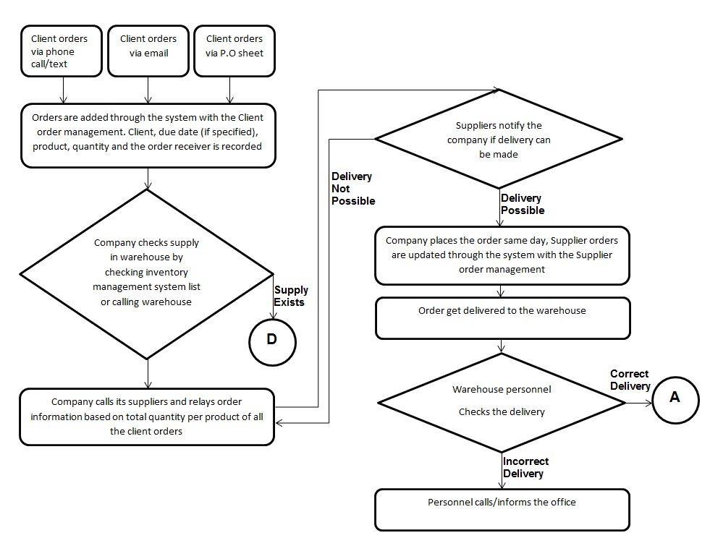

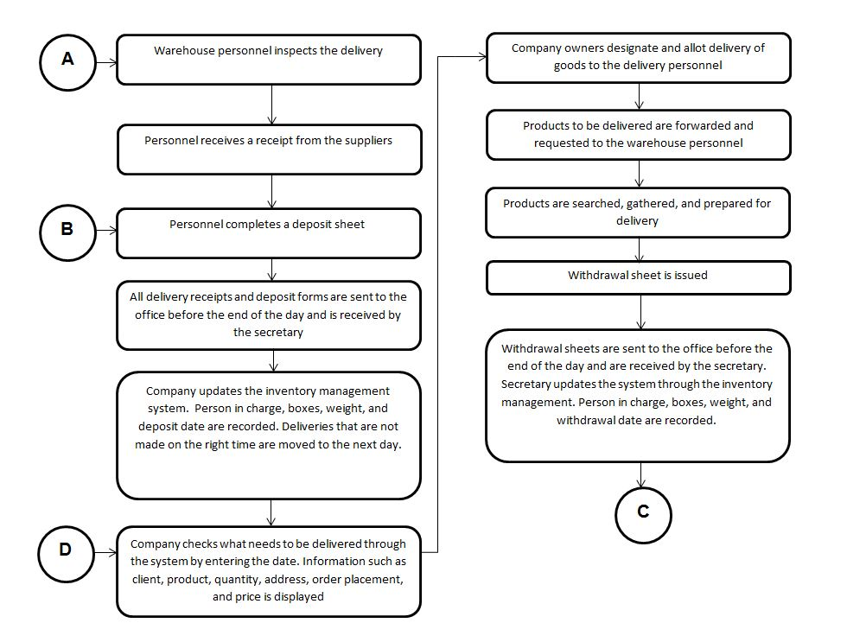

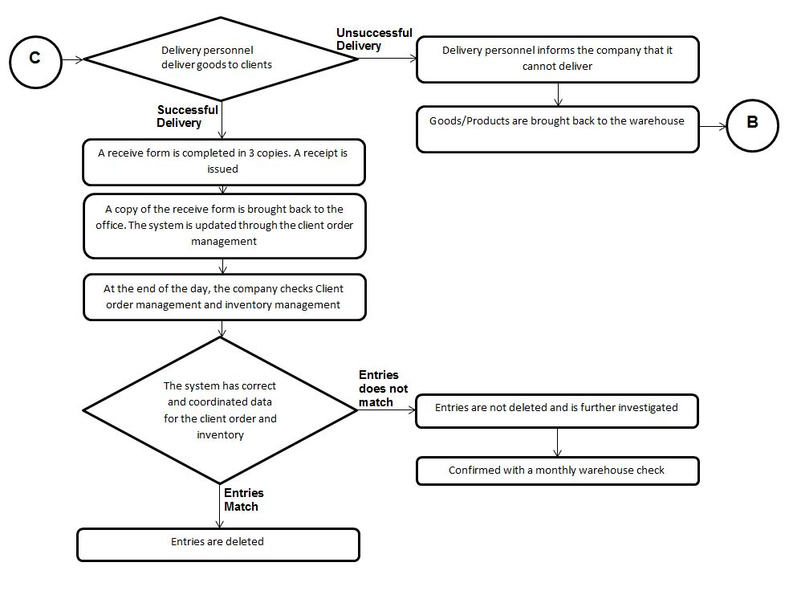

**Appendix B – Interview Transcript**

Date of interview: January 23, 2016

**F** - JR Flores, Managing Director

**J** - Jude Atienza, President

**T** - Student Interviewer 1

**H** - Student Interviewer 2

**V** - Student Interviewer 3

H: Good morning, thank you for your time for this interview.

F: Sure no problem, let’s start.

H: So, could you give us an overview of your company?

F: So basically, what the company does is that we have suppliers and in turn, we supply imported meat and seafood in the form of six hundred products to establishments. We are dealing with fifty suppliers that supply us and then two hundred customers that we supply ourselves. As we are in food distribution, our products are meats (such as ribeye), seafood (such as salmon), chicken and whatever you eat usually in restaurants that are imported.

V: How does the process of ordering go?

J: For the orders, since the clients usually either calls us, sends a PO, or emails us on their orders, then from there we first call the warehouse if those are available if it is available then it just waits there for processing until the delivery date. If it isn’t available though, we go through our suppliers, asking who can deliver this product in this quantity, then we place the order.

T: What information do you usually gather for your business?

J: For the orders, we record the client, then who received the order, product, and quantity. the PO number is also recorded if we received the order via PO. And delivery date if the company has a requested date, otherwise we take it as a delivery two days later.

F: In the inventory system, when we get our supplies, we get the amount multiplied by the quantity to get the price. We record those figures in excel to mark that it exists in the inventory. Once the item is sold, we deliver, delete the entry from the excel file. That’s about it.

T: Can we get a sample copy of your inventory file?

F: We can provide that.

V: The inventory file has all the products in one file?

J: No, there is one excel file for the meat and another for seafood.

V: How does the process of inventory go about?

J: The suppliers drop the products off at our warehouse. We then supply the products to restaurants. But these suppliers, sometimes we get one product here one product there and ends up say, end ups here or the first supplier nag end up siya to everyone. Get it?

T: Where do you usually keep the record of inventory?

F: We keep a record sheet of our purchases from our suppliers. Do you guys need a copy of this? The warehouse staff keep track of two sheets, the deposit and withdrawal sheet. Deposit sheet tracks the arriving of products in the warehouse. Withdrawal sheet tracks the release of products from the warehouse.

T: So the warehouse people keep track of your inventory?

F: Ah yeah, they provide the sheet to eventually be turned in to the secretary. So she’s the one entering and tracking everything.

H: Who has the access to the excel file?

F: The secretary has access.

H: How many deliveries do you have in a day?

F: In a day, deliveries average at least ten, and a hundred per week.

T: Do you keep track of your deliveries? Do you also record it in an excel file?

F: Yeah, do you guys need a copy of that?

Interviewers: Sure. Haha.

F: Our secretary tracks everything now. So for example, there is delivery tomorrow. She writes an excel. She has the ability to select a date from the file, to show all the deliveries completed for that day.

J: I think we can check it out.

F: Yeah, just show them.

V: So upon delivery to your customers, do you get a receipt sheet?

F: Oh yeah. We have a sales invoice so they have a signed official receipt on the delivery day as proof.

J: We do the process of the official receipt manually. We don’t want it computerized.

**\*Shows receipt\***

J: Our inventory is by the kilos, by the boxes. So every box has around 25 to 30 kilos. The weight varies in different boxes however.

V: So how do you keep track for let’s say ung expired goods?

F/J: It says there. The production date.

V: Do you mark it somewhere?

J: It’s certainly there. But we don’t take it into record anymore. Because our products are fast moving. and then it’s good for three years before they expire. But you can put that in.

H: How does the customer order from you?

J: They call us. and then we forward the order to our secretary.

T: So your secretary also records it in an excel file?

J: Yea, there’s a delivery sheet. When a customer calls us, for example restaurant A calls us. We’ll tell our secretary, restaurant A orders 2 pieces of salmon with the date. The format as goes: date of order, the product, the date of delivery and the company name. She records it personally.

J: I’ll show you.

**\*Shows excel sheets\***

F: So this is an example of an inventory sheet. So here are our products, around ten kilos, basically each box has usually about ten kilos per box.

V: Is kilos your standard of measurement?

J: Yes.

J: So this is the deposit slip for the warehouse in red; a withdrawal slip comes in yellow for identification.

F:The process is mostly manual. Our secretary will make a table for every product in our inventory, in the excel sheet.

V: The entries in the excel sheets, when do they get removed?

J: They are removed when I give the order.

F: Usually I just check it. If it evens out, like this one if its ‘fourteen’ on one side and the other side matches, I take it out already. It usually should match with the stocks, so when it matches with the actual I take it out.

J: So here are the products, for example this box weighs 4.6 kilograms. The weight varies per box.

F: As you can see, there are different formats for meat and seafood for easier identification.

F: So before we take it out, there’s like a three way check. We first check the system, then the withdrawals and then the actual stock in the warehouse.

H: What about the orders?

J: We just give the order specifics to the secretary then she places it in excel.

H: Who sets the due date for the orders?

J: We do, for example this restaurant orders then I say we can deliver by ‘tuesday’… these products that they indicated.

F: So here’s an example of a PO, though they usually just email us.

J: These are the orders.

T: So after the deliveries were done, you write down “done” at the last column in the sheet.

J: It isn’t that necessary, but these orders are definitely done already. Maybe someone forgot to put it down?

J: Definitely everything will be done on that day. If we cannot, we just move it to the next day.

V: So these are the orders for the client.

J: Yeah, for our client. So for our purchases, someone will do it. We just check this out and then call the suppliers.

V: How do you keep track of your order?

J: We just call them. For example, for delivery due on November 9, two day lead time, this was ordered November 7. So take this into account then contact the suppliers. For example we add all the frozen salmons, then we’ll call suppliers that we need 2 pieces of frozen salmon. The suppliers will deliver it to our warehouse. However, sometimes we keep an inventory also to make it easier to check.

F: We do inventory once a month from our warehouse.

H: So if it is already due, do you contact the clients to check if they already receive it?

J: No, we just check the receipts the next day. Actually our drivers tell us also, if the deliveries are done that means everything is done.

H: Do they give the receipts?

J: Yes, they will give that back to us. Cause the drivers are the ones who hold that, not us.

H: How do they know where to deliver? Like the address..

J: We just give the address. They are familiar with our clients’ addresses already. However, if the client is new, we text them the address or we write it down. On our receipt, there’s an address there. Sometimes we write down the whole address for them and to just GPS to help locate it.

T: What is the timeline of your deliveries?

J: Two day lead time.

V: What are the factors affecting delivery?

J: Traffic and fortuitous events like floods

T: How does the company ensure complete delivery of goods?

J: At the end of the day, the drivers will text if the deliveries are good or if they aren’t able to deliver the goods because of whatever reason.

V: How does the company keep track of the status of the delivery?

J: We contact the drivers.

H: How many deliveries do you usually have in a week?

J: 100-140 deliveries

H: What does type of items do you keep in the inventory?

J: Beef, pork, lamb, seafood, and chicken

T: What are the qualities that you record in each product?

F: Usually in the box, they have production date, expiry date, and other details

V: Does it include quality?

J: For the meats, quality is included, only some are included for seafood however.

When you say quality, we use the brand as the basis. There’s 3rd party doing quality control in other country (e.g. USA) 5 qualities such as: “prime, choice, select and ungraded“ for the meats.

F: ..but we count it as different products even though it is same part of meat (e.g. rib eye).It differs by grade. The customers are aware of the quality they order.

**\*Interviewees give important documents to interviewers.\***

H: Do you have minimum purchase orders like minimum kilos?

J: We used to have a standard for that., but now it depends on the area (e.g. Makati).

F: Cause we have a lot of deliveries in Makati, we can cater smaller quantities.

**\*Gives the price list\***

T: Usually, are the prices the same or do you adjust your price?

F: Actually, we give a fixed price, but once volume increases in the concept of supply and demand, the prices will vary. For example, someone can order 10 kilos, there’s a standard price, but if they order like 100-500, from 420, the price can definitely go down so we adjust.

T: How do you calculate for the price?

F: We standardize the price ourselves, so we have the prices from the direct importers they have the prices as well. We are in charge of the profit amount.

T: In the inventory, you need to keep track like where the supply came?

F: I have 3 suppliers, I should know who the supplies for a certain day came from.

V: When do you mark the product as not anymore in your warehouse? Like when it leaves the warehouse or when your client receives it?

F: When it leaves the warehouse. We use the deposit/withdrawal sheets. We once lost the papers and the record for that day went missing.

H: So if you delete, will it be gone permanently?

F: The record will be lost.

J: Let’s give them the documents about the tracking

**\*Gives the interviewers other important documents, forms, and etc.\***

H: To summarize, your inventories and orders are done manually by using excel sheets.

F: Yes, I think it’s fine the way it is, but it could improve with a software. Especially to track deliveries, we want to see the total in the end.

Interviewers: That’s all. Thank you so much for your time.

**Appendix C – Sample Forms and Reports**

*This chapter contains the different sheets and reports used by the company as part of its business process.*

*C-1. Inventory Sheet*

The Inventory Sheet is used to keep track of what products are being deposited and withdrawn in the warehouse. The information stored are the type of meat, weight, quantity,and date.

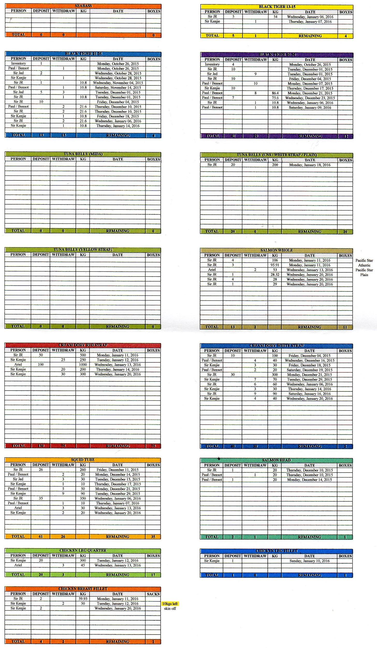

*C-2. Daily Client Orders Sheet*

The Daily Orders Sheet contains all the orders taken in a day which include the receiver of the order, company, products ordered, quantity, price, delivery personnel, due date, PO#, notes.

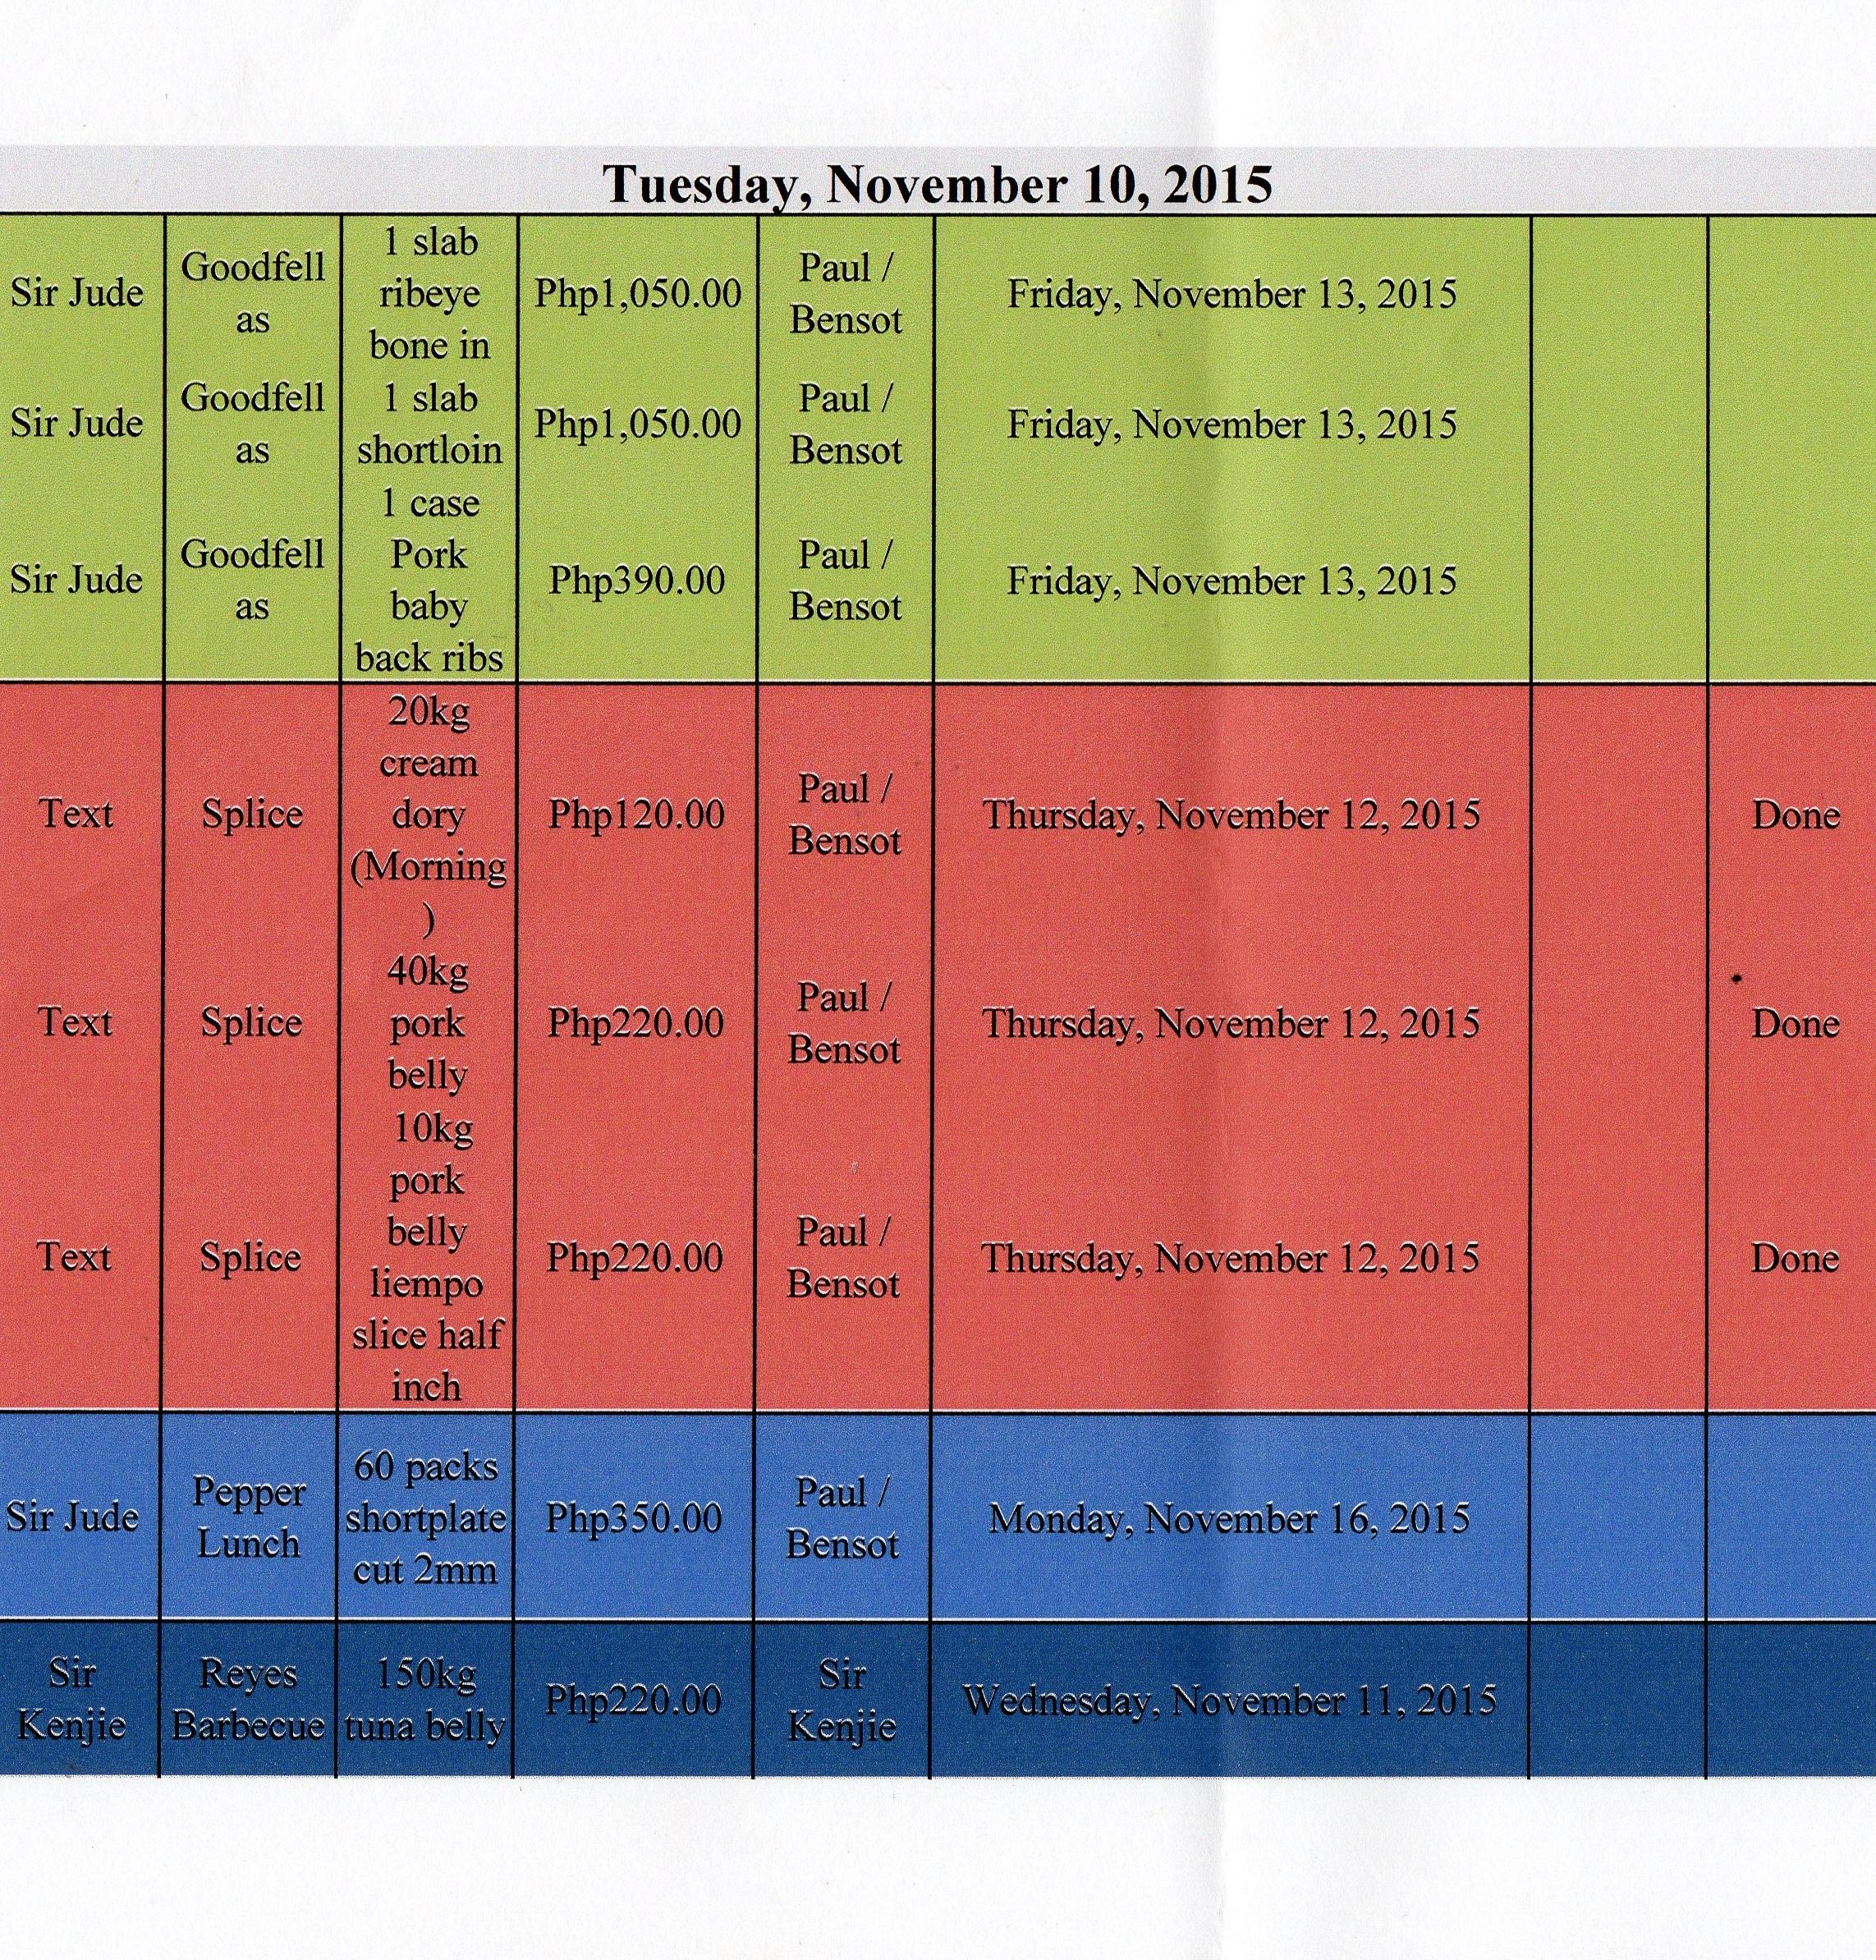

*C-3. Deposit Slip*

The Deposit Slip is issued when new supplies are delivered to the warehouse. It includes deposit slip number, company name, date, product description, no. of cases, and total weight.

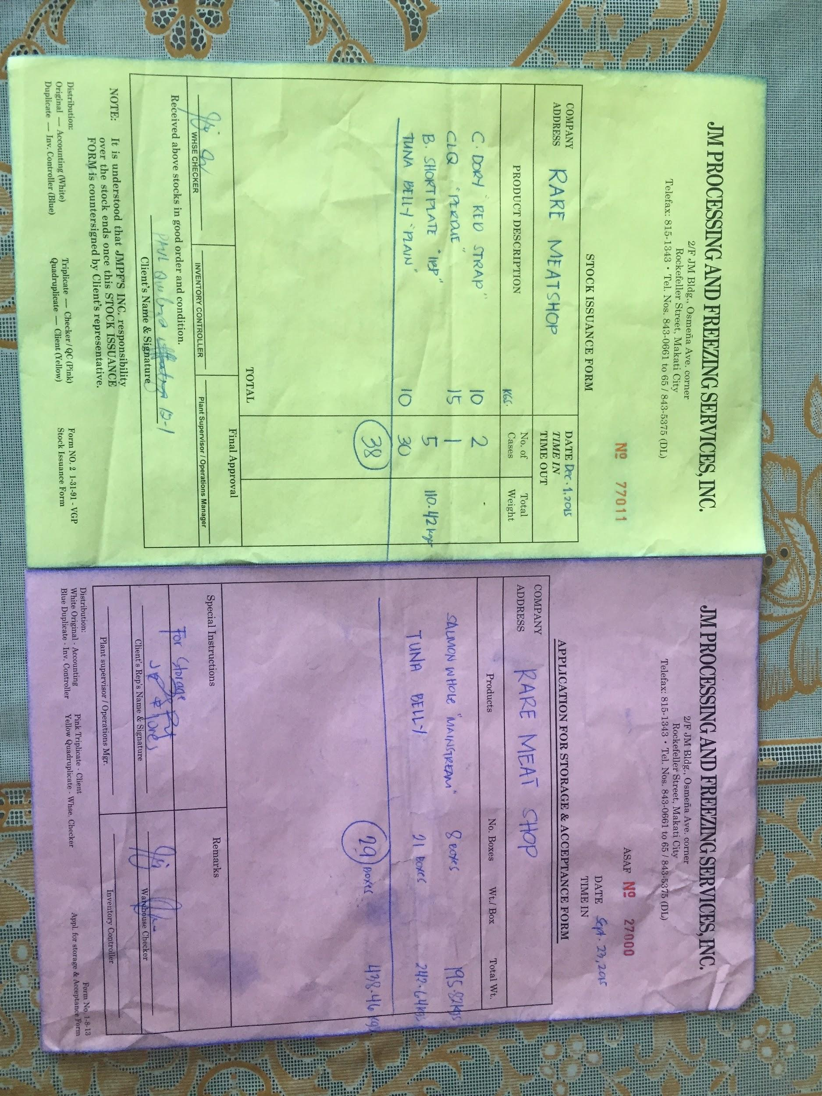

*C-4. Withdrawal Slip*

The Withdrawal Slip is issued when the company gets products in the warehouse. It includes withdrawal slip number, company name, date, product description, no. of boxes, and total weight.



*C-5. Receive Form*

The Receive Form is issued when the client receives the order.

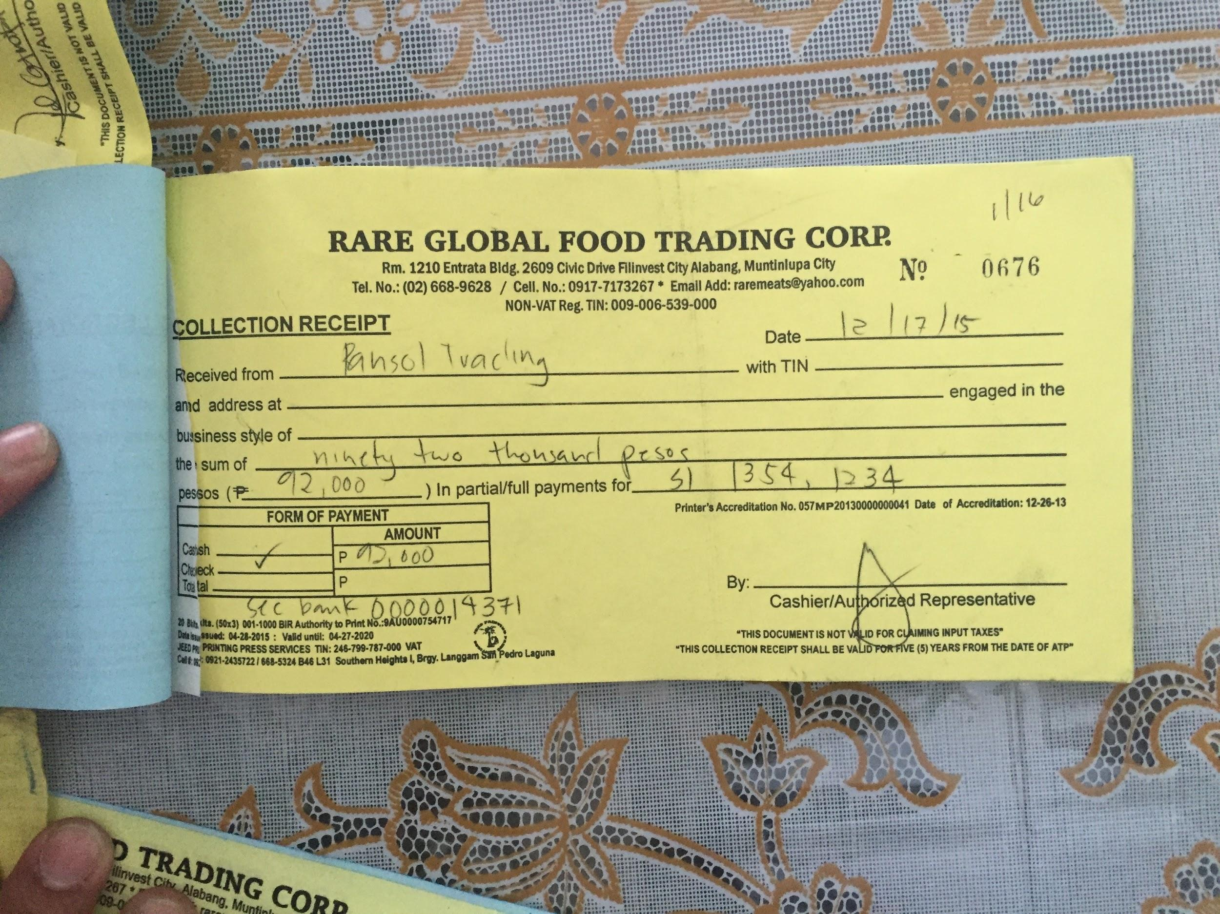

*C-6. Sales Invoice*

The Sales Invoice is issued after the client receives the order.

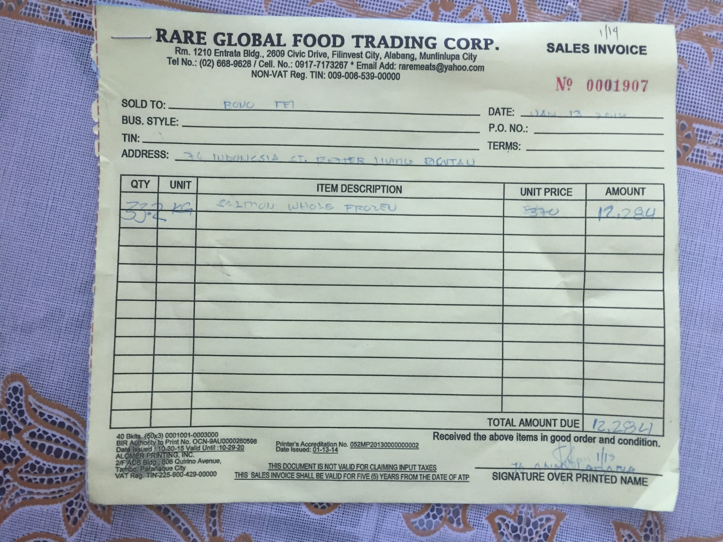

**Appendix D – References and Acknowledgement**

### Jan Robert Flores, Managing Director of RARE Food Global Trading Corp.

### Jude Atienza, President of RARE Food Global Trading Corp.